[AWS Serverless Microservices with Patterns & Best Practices](https://medium.com/aws-serverless-microservices-with-patterns-best?source=post_page-----c0116d383eeb--------------------------------)

**What is AWS Lambda?**

AWS Lambda is a compute service that Runs code without thinking any servers or underlying services. It is a Serverless function that you only responsible for your actual code.

*AWS Lambda is an event-driven, serverless computing platform provided by Amazon as a part of Amazon Web Services. It is a computing service that runs code in response to events and automatically manages the computing resources required by that code. It was introduced in November 2014.[1]*

We can trigger Lambda from over 200 AWS services so that means Lambda has incredible natural integrations with AWS resources and also able to integrate SAAS applications.

Run code without provisioning or managing infrastructure. Simply write and upload code as a .zip file or container image. Automatically respond to code execution requests at any scale, from a dozen events per day to hundreds of thousands per second.

Save costs by paying only for the compute time you use by per-millisecond instead of provisioning infrastructure upfront for peak capacity.  
we call this pay-as-you-go. This is common feature for Serverless services, but for AWS Lambda, AWS charge you as per-millisecond level, its really fair cost when it comes to pay as-you-go model.

Optimize code execution time and performance with the right function memory size. Respond to high demand in double-digit milliseconds with Provisioned Concurrency.

**How does AWS Lambda work?**

We said that AWS Lambda fits into the event-driven architectures. So, As you can see the image AWS Lambda triggers by event and executes the function code.

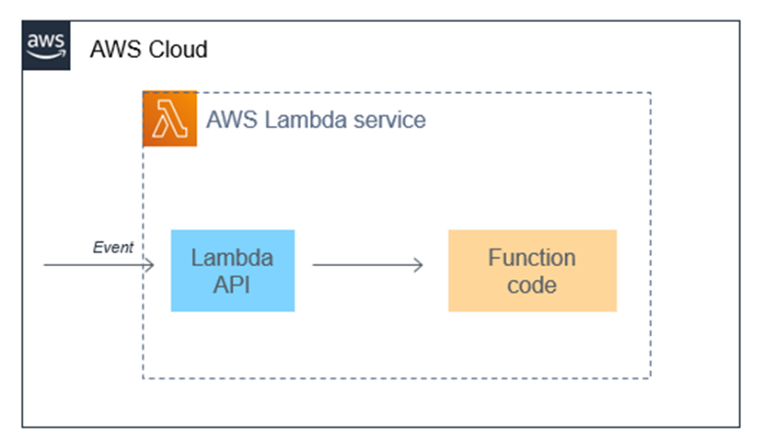

Each Lambda function runs in its own container. You can think every lambda function as a standalone docker containers. When a function is created, Lambda packages it into a new container and then executes that container on a multi-region cloud clusters of servers managed by AWS.

Before the functions start running, each function’s container is allocated its necessary RAM and CPU capacity that parameters are configurable in aws lambda.

When the functions finish running, there is a calculation; the allocated RAM and the function execution time is multiplied and calculated charged cost to the customer. So that means customers charged based on the allocated memory and the amount of execution time the function finished.

AWS Lambda’s entire infrastructure layer is managed by AWS. Clients don’t get a lot of visibility into how the system is running, but they’re also don’t need to know about underlying machines, network contention, etc. they don’t have to worry about things like; AWS handles this itself.

Using AWS Lambda can save you time on operational tasks because the service is fully managed.

When there is no infrastructure to maintain, you can spend more time on application code and your actual business logics; that means it giving up the flexibility about to your infrastructure.

**AWS Lambda Main Features**

As you remember that we said that Lambda is a compute service that lets you run code without provisioning or managing any servers.

Now lets focus on AWS Lambda Main Features.

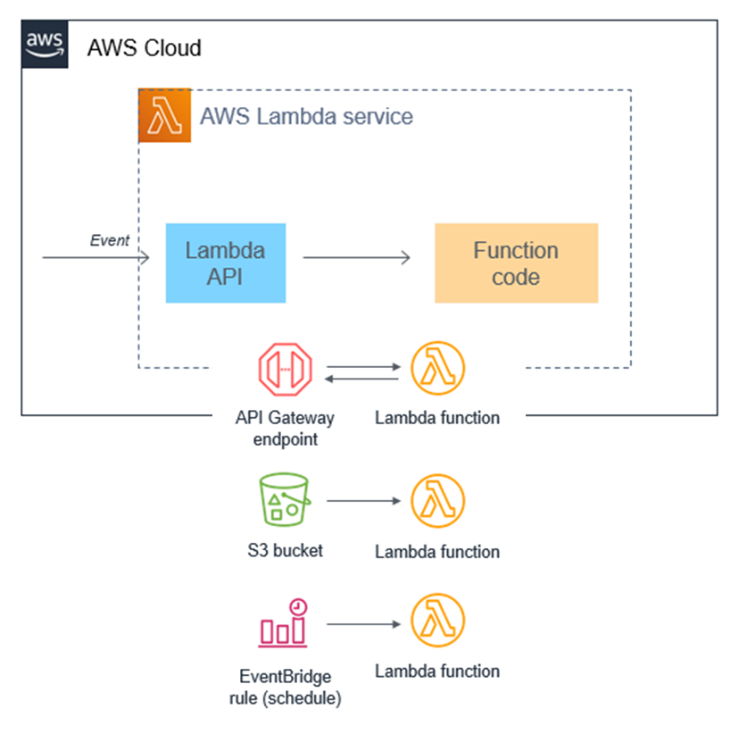

**Cost Saving with Pay-as-you-go model**  
Customers charged based on the allocated memory and the amount of execution time the function finished. You only pay for the compute time and there is no charge when your code is not running.

**Event-driven Architecture with Lambda**  
Lambda is an on-demand compute service that runs custom code in response to events. Most AWS services generate events, and many can act as an event source for Lambda.

**Scalability and Availability**  
With lambda you can run code for virtually any type of applications or backend services all with zero administration. Upload your code and run your code and scale your code automatically with high availability.

**Supports Multiple Languages and Frameworks**  
Lambda has native support for a number of programming languages including Java, Go, PowerShell, Node.js, C#, Python, and Ruby code, and provides a Runtime API that lets you use any additional programming language to write your functions.

**AWS Lambda Function Code**

Lambda runs instances of your function to process events. You can invoke your function directly using the Lambda API, or you can configure an AWS service or resource to invoke your function. You can find the image below, which is a Lambda function with Node.js versio